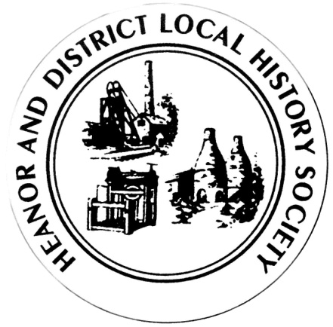
We want your memories! As part of an ongoing project, the Heanor & District Local History Society wants to hear from YOU.
We would like to establish a collection of people’s memories about the area - it can be from any period, and from any part of the district. And ANY subject - whether home life, work life, shopping, leisure. It doesn’t matter how trivial you may think your reminiscences are, they will help form part of a much bigger picture, which we can use to assist our future research, publications and newsletters.
This is nothing new of course; we have always asked for this from our members, but have now decided to use this method to try to prompt people to give information on specific issues.
So, every couple of meetings (if it works), we will distribute a new form, on a different topic, and with different questions. There is no deadline. You don’t have to take part in all, or any, of the topics. Likewise, you don’t have to be a member to take part - all that we ask is that it is something to do with the Heanor area, or involved Heanor people. If you can think of someone else who may like to help, please feel free to pass a form onto them.
This month’s topic is: First Job.
How to pass the information onto us:
- If you normally attend our meetings, just fill in the form and hand it back at the next meeting.
- If you don’t attend our meetings, then please send us an email with the information (mail@heanorhistory.org.uk).
We would rather that you didn’t send us information anonymously, but nobody’s name will be published unless you have specifically given us permission to do so. In particular, we WILL NOT publish anything which of a personal or potentially sensitive nature.
Name | Address
Telephone
Email address
Are you willing for your name to be linked to any information supplied? |  | Yes / No
Would you be prepared to discuss this or related information further? |  | Yes / No

P.T.O.

Please try to recall your first job, whether this was a permanent job, or something temporary, or even a summer-job when at school.
How old were you, and, roughly, what year was it?
What was the job?
Which company did you work for, and where were they based?
What were your working hours?
How did you get to your workplace? Was it an effort to get there on time?
What did you do for food whilst at work?
Name anyone you can remember from work on that first day (supervisors or colleagues).
What was particularly memorable about the first week?
How much were you paid for the week/ month?
Please use a separate sheet if necessary.
Thank you

